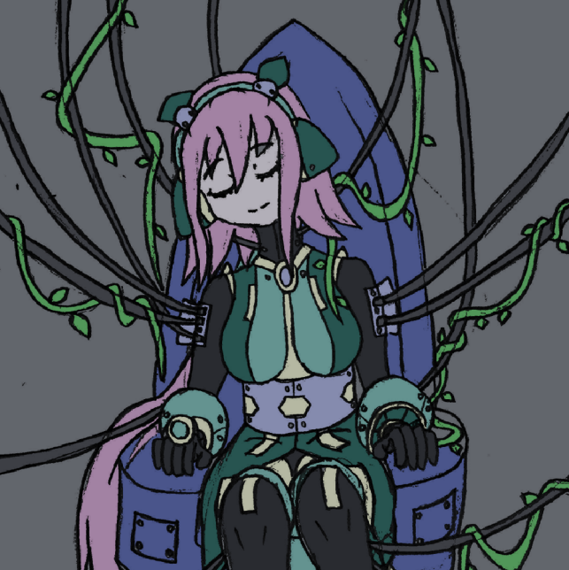

**<Lost Arcadia>**

<Group KO>

Ghislain Clermont

Luojia Yan

Xuan Li

Jia Gao

Xiyue Li

Amrou Abdelhadi

Revision: 0.0.0

# Contents

Executive summary

Overview

Related games

Player composites

World

Characters

Progression graph

Art direction

UI storyboards

Tags and dialogue

Technology plan

Software architecture

Controls

Level design

Mechanics analysis

Schedule

Budget

Change logs

Meetings

Skill & Monster description

# 

Executive summary

In Lost Arcadia, an action platformer with a post-apocalyptic background, uncover the mystery of the world with Iris, a female robot. Defeat the monsters with skills and wits, persevere in the struggle against complicated surroundings, and make everything back to normal.

Selling point:

- Platformer mechanics with Shooter controls for unique gameplay.

- Flexible, easy to use mouse-based support skills

- Unique post-apocalyptic story

- Likable main character

Overview

Genre: Single player 2D action, platformer

Platform: PC

Target Audience: Teens+, Platformer/Shooting fans

Setting: post-apocalyptic

Goal:

Plays like: Mega Man meets No Time to Explain

Mechanics:

- <#1> Jumping

- <#2> Shooting

- <#3> Mouse-controlled skills

- <#4> Absorb enemies for Temporary power-up

Reference Art:

- <#1> Mega Man X

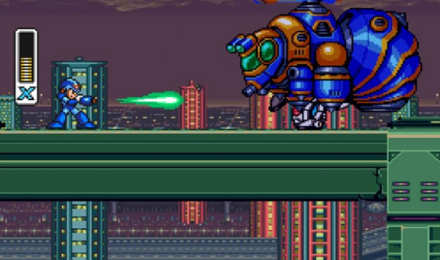  
SRC:https://store.capcom.com/us/product/525302/mega-man-x-legacy-collection-steam

- Megaman X is the main inspiration for the game, both on gameplay and art sides. The player will be able to jump and dash in the same way than in Megaman X, and the player will also grow stronger mainly by obtaining new powers. Artwise, the design of Lost Arcadia’s main character design will be inspired by that of the humanoid robots X and Zero, being a humanoid robot too.

- <#2> No Time to Explain

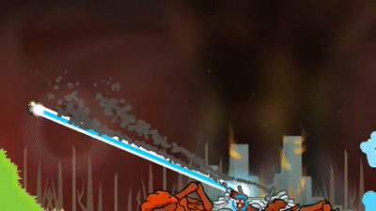

https://makeagif.com/gif/no-time-to-explain-remastered-pc-60fps-gameplay-1080p-EbiYJy

- No Time to Explain is a 2D platformer that, just like Lost Arcadia, used the mouse to aim and shoot the character’s weapon. Furthermore, weapons were not only given an offensive utility, they were also used to control the character’s movements, giving further depth to each weapon. Lost Arcadia also aims to give multiple purpose to each support skill, being usable to enhance the character’s mobility, to defend against enemies, or to expose the enemy to the primary weapon’s line of fire, each in their own ways.

- <#3> Icey

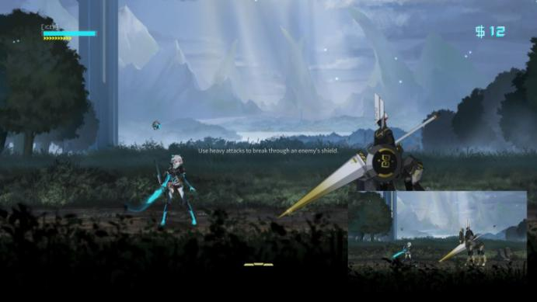

http://operationrainfall.com/2018/04/26/tbt-review-icey/

- ICEY is the second biggest inspiration for Lost Arcadia. The setting is mainly inspired from this game’s atmosphere, in which the main character is a robot waking up with nothing but enemies rampaging outside. The maps will also resemble many of ICEY, with verdure overtaking futuristic locations.

Related Games

<#1> Mega Man X



<https://switchplayer.net/2018/09/03/mega-man-x-legacy-collection-review/>

Mega Man X, as known as Rockman X in Japan, is a Mega Man series of action games released by Capcom. Rock Man X was first released in December 1993 in Japan and then went to North America next year. It was initially implemented for console controllers on TV and ported to the PC platform later. Mega Man X was a new type of robot created by Dr. Thomas Light and has his own thought to make decisions. The gameplay is similar to other Mega Man series with several new features. The selling point of this game is that this is one of the Mega Man series and it also has its unique IP. They do not have to contribute a lot to the new Mega Man series because the Mega Man series already has its plots and stories and world story. What they need to do is copy the success and extend the story and add some new features.

It is successful because during that period there were not so many great games for players to choose and the technology was limited. And Mega Man becomes popular due to its gameplay: weapon charge, upgrade system, soundtrack, storyline, etc.

The failure is also because it is the series of Mega Man, it lacks innovation. It stays in its safe area just want to keep the Mega Man fans.

Since nowadays collaboration becomes a trend, the Mega Man series is now collaborating with Dragalia Lost which released by Nintendo and Cygames on IOS and Android. This kind of advertisement will be a double win because Mega Man is a well-known IP and Dragalia Lost is very successful in mobile games.

<#2> No time to explain

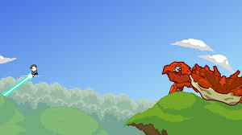

<https://www.microsoft.com/en-ca/p/no-time-to-explain/br07qwgdppl1?activetab=pivot:overviewtab>

Genre: Platform, Action

Publisher/Developer: TinyBuild

Platform: Linux, Microsoft Windows, Xbox, Play Station

Engine: Unity

Mode: Single Player

Release: Windows, OS X, Linus, Xbox One, PlayStation 4

No time to explain is a browser game released in January 2011 on Microsoft Windows, Linux, PlayStation 4 and Xbox One. This game is a 2D side-scroller mainly using a weapon as propulsion. The protagonist uses its laser gun to shoot a laser beam to help him conquer the difficulties of the level during the limited time.

This game was under development in 2011, during those years, flash games are huge things in the game industry. Different from other flash games, the levels of this game are built out of blocks. We are inspired by the design of the weapons, the weapon in No time to explain is not only used for an offensive purpose, but also for supporting the protagonist. Like our game, the weapon of Iris can cast energy blast as support to reflect the enemy’s bullets and make it possible to double jump.

There is no doubt that the weapon design is the shining point for this game, but the selling point is not that great so that this game is played by the minority. The control system is quite simple, but it is not new player friendly because it is hard to control the directions. The failure of this game is due to its limited control system and physical system. Players will get bored after playing for a while because it is hard to control the character and tedious movement.

<#3> Icey



<https://store.playstation.com/en-us/product/UP1519-CUSA08085_00-ICEYPS4VER000001>

Genre: Hack-and-slash

Mode: Single-player

Developer: Shanghai FantaBlade Network Technology Co., Ltd.

Publisher: X.D Network Inc.

Platform: Windows, PlayStation 4, Nintendo Switch, iOS, macOS

Icey is a 2D side-scrolling hack-and-dash game published by X.D Network and developed by Shanghai FantaBlade Network Technology Co., Ltd. This linear game can be played since beginning to the end with dialogue trees. The players are free to choose the subtree dialogues and plots. This game is talking about a female cyborg named Icey to fight against evil Judas, who has the devil's mind to destroy the whole world. The interesting part of the game is that the narrator will guide you, but you can still make your own choice and he will get angry and frustrated. The achievement system is implemented in this game and players need to adventure and explore the plot by hints given by the narrator.

This game is a huge success due to several reasons: domestic independent R&D, offline action, nice hit effects, attractive storyline, fancy narration system, etc. Before this game released on Steam, over 2 million players have purchased this game and now it has mostly positive feedback on Steam. The most interesting part of the game is the combination of interactions with player and narrator through user interfaces, depends on the decision players choose, different side plots will trigger.

Our game is inspired by the storyline, game mechanics, plots of the Icey. Iris’s movement is similar to Icey’s movement including dash and jump, but Iris cannot double jump unless with the help of energy blast.

Player composites

Name: Evan Stanley

Age: 25

Game Schedule: Evan plays video games on weekend or after work between 7pm and 10pm when he has spare time. He plays game three to four times a week (20 hours/week) in order to reduce his working pressure.

Game Location: Evan lives alone. However his parents live at the suburb of the same city as him. He only plays games at his own home.

Game buyer: Evan himself or his friend buys the game for him.

Platform: Evan plays games only on his laptop (Windows and MacOS) which does not have sufficient performance for large AAA games.

Game partner: During business day, Evan plays games alone, because his friends are busy with their own work. However, he always chats on discord and tries different games together with his friends.

Selling point: Evan found the art work and the style he likes the most, especially for those of the main character, Iris. In addition, he also praises about the game mechanism, such as reflection of the laser on ice wall.

Non-game image: Marvel comics

Disposable income: $4000/month

Licensed content: Evan is a big fan of Lego and Marvel superheroes.

Game time competitor: Since Evan works from 9am to 5pm, and spends 1 hour on community, he has to get up at 8am sleep at 11pm. Thus he has about 4 to 5 hours of leisure time to play video games and watch TV shows. However, his parents visit him about twice a month, during which he has to spend time on family.

## World Story (Brief)

A female robot fighting for saving the world.

## Story (Detailed)

In the distant future, nature was completely gone from Earth. Now seeing the effects of the absence of nature, the government issued a large bounty to whoever would be able to restore nature. Many scientists shifted their research onto the rebirth of Nature. However, to protect their own bounties, certain scientists tended to sabotage other scientist teams.

Our laboratory mained their research onto a humanoid robot, Iris. They implemented the mind of one of their scientists into the robot and gave her tools to analyze and extract fossils of nature, so that she could fetch process the data more easily and reliably than an AI-driven robot could, but also gave her weapons to protect herself in case of sabotage.

However, another scientist team rushed their project and created a virus that could regrow nature out of anything organic. The virus was however far too strong and spread far too fast, contaminating their laboratory in no time. Every human being turned into trees in a matter of minutes. And before anyone could figure out there was a virus outbreak and find a way to counter it, it spread throughout the whole world, turning all of humanity into trees. Some animals who happened to have resistant genes still couldn't completely resist the virus and mutated into nature-like monsters.

Iris was nearing completion when that happened. She was put to sleep again while they were doing some of the final adjustments. However, all of her scientist team suddenly turned into three, leaving her asleep. Only one of them, Hiroki, who happened to be near the machine used to implement Iris' mind, used it to transfer his mind onto a computer, saving his conscience but not his body.

Months later, one of the monsters accidentally wandered into Iris' lab, and started rampaging around, destroying multiple machines. It caused a shock onto Iris, awaking her up. Unable to identify the monster in front of her, and detecting its hostility, she exterminated it with the weaponry (the drone) she was given. She then settled to try to find any human in her lab, without any success. Until a computer's speaker caught her attention. Finding the scientist who managed to at least save his mind, they team up together to try and figure out a way to save humanity. (The scientist is switched to a drone)

They start by using Iris' tools to identify the source of the virus, and figure out where the virus was developed. Heading to the laboratory that developed the virus, they find a large machine, actively producing the virus. After defeating the monsters protecting the machine, they figure out together a vaccine to the virus, and modify the machine to spread the vaccine instead, saving humanity.

Game Characters

1. Iris

Motivation: To uncover the reason why human have turned into trees, and try to save humanity.

Likes: Nature, her teammates

Dislikes: Pollution, pranks

Family/Friends: Human, Hiroki

Enemies: Monsters created by virus, evil scientists

Vital Statistics: As a robot, Iris is stronger compared to humans, and she is not affected by the virus.

Tools/Weapons: The drone (that can shoot bullets and laser) & The Space-Flux Manipulator (that can cast supporting skills)

Personality:

Iris has the full attitude needed to be a scientist. She is very curious and is always looking for explanations on unanswered questions. She is always calm and objective in her judgement. She is also smart and has a good memory. On top of all that, she is very friendly toward everyone, making her popular within her laboratory. However, with her naivety and her difficulty to view other things when focused, she has also become an easy prank target. After she transferred her soul into the robotic body, she also started struggling with strong emotions, causing her system to “lag” and cause stuttering in her voice.

Background:

Iris joined her laboratory immediately after graduating from University. Her field of specialization was Biology, and she was particularly interested in past records of nature, in hope that one day, she would be able to see real, non-artificial flowers.

Then, when the government announced the bounty for reviving nature, her laboratory formed a large team to fulfill that bounty, and Iris became an important part of it as the laboratory’s best biologist. The direction they took for it was to create a robotic body in which the person that transferred his soul into it would be able to merge the analyzing speed of computers and the thought process of humans, which could not be replicated through AI. And with her already high knowledge, Iris became the candidate to be the host of the robotic body.

Iris’ soul was transferred into the body, and her team repeatedly put her to sleep for maintenance. However, when her body was nearing completion, the tree-morphing virus was released, and no one was able to wake her up again. Until 3 months later, when a mutated monster sneaked into her lab and started destroying the machinery she was connected to, causing a shock that woke her up.

1. Hiroki

Motivation: Support Iris in her quest to save humanity.

Likes: Revolutionary science, safety

Dislikes: Unsafe experiments, Delta Genetics

Family/Friends: Human, Iris

Enemies: Monsters created by virus, evil scientists

Vital Statistics: Before turned into trees, Hiroki transferred his soul to the computer, then Iris helps transfer him to the drone

Tools/Weapons: Himself

Personality:

Hiroki is a very friendly and energetic man. Although he struggles with a lot of the theory of science, he redeems himself as a scientist by is hard-working attitude, his imagination and his thoroughness. As he’s often paranoiac, he makes sure that his experiments are always as safe as possible.

Background:

After graduating from university, Hiroki joined the Delta Genetics Laboratory, a science team that focuses on genetic experiments. This team had received a lot of praise for giving fast results, but after joining their team, he discovered that they skip many crucial safety steps for their experiments. Growing disgusted at these unsafe working conditions, Hiroki left the team, and became a crew of Iris’ laboratory.

After having proven his worth, he became the leader for the Soul Transfer project, and succeeded in being able to transfer someone’s mind into a computer. Once the bounty on reviving nature was announced, he cooperated with the laboratory’s mechanical team to create a robotic body which would be entirely controlled by someone who soul transferred into it, and be able to execute all the tasks needed to fulfill the bounty with high efficiency.

However, as the project was almost complete, the tree-morphing virus was released, and as Hiroki noticed his body was turning into a tree, he quickly activated his Soul Transfer machine and transferred his mind into the computer. With no one remaining to manipulate the computer, he realized that he was now stuck with no way out. Until Iris woke up 3 months after.

plot graphs  
  
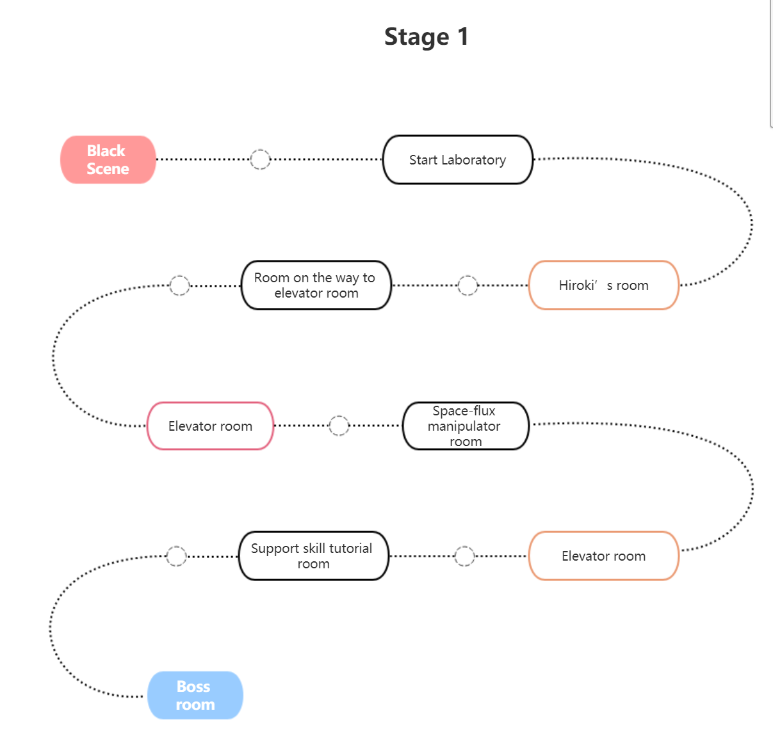

Stage 2: outside the lab - inside the lab

Art direction

Lost Arcadia will be using pixel sprite based assets for the protagonists, skills and monsters, designed by our artist. The background, other graphic related will be from the Internet.

The world of Lost Arcadia is a conflict between two opposites: Sci-fi and Nature. Sci-fi assets are represented using vivid colors and clean shapes, while nature assets are represented with less strong colors and more abnormal shapes, to represent that this is not the ideal of nature.

**Iris**

Iris’ appearance is inspired by Zero from both Megaman X and Megaman Zero. With her agile movements, her proportions are on the thin side, and she has a long ponytail that adds to the flow of movement. Her head proportion is 1/4, making it big enough to see facial expressions, while keeping a realistic body posture within 64x64 frames.

Her sprite’s base poses:

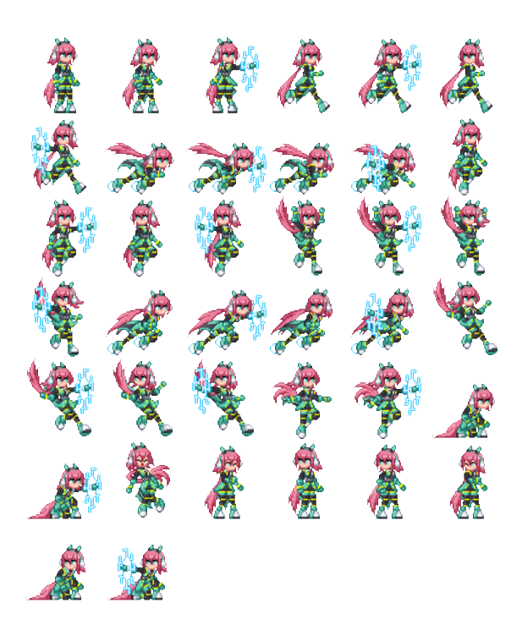

Her Faceset:

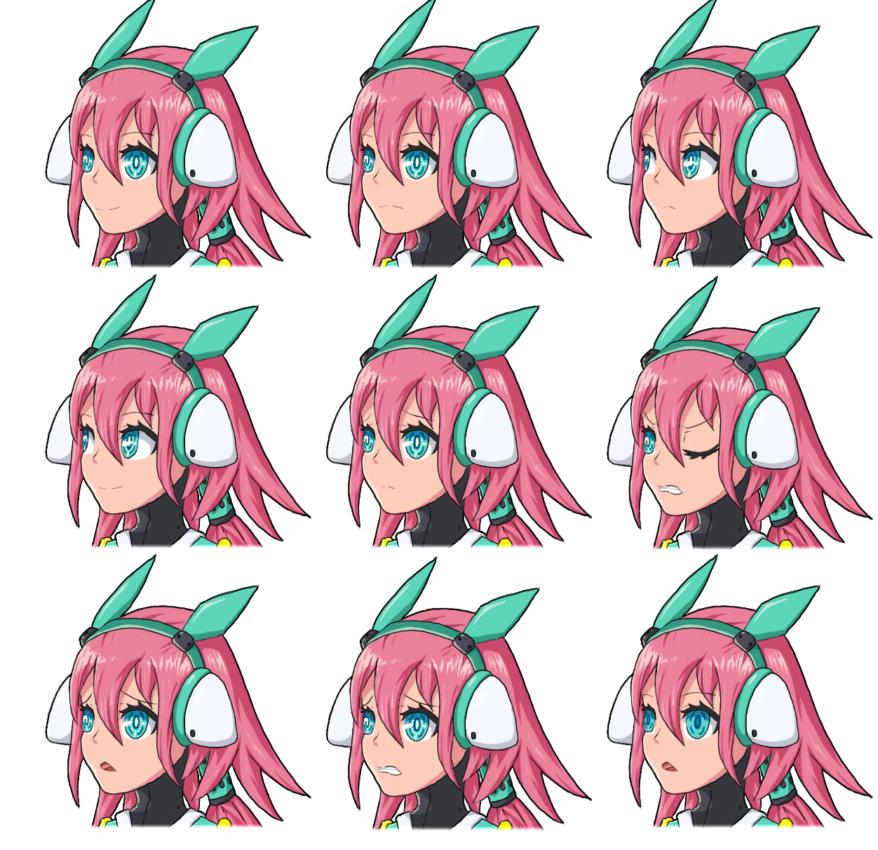

**Hiroki**

Hiroki is designed as a circular drone, making its animation simpler to manage as it rotates to aim toward the cursor. It’s color scheme is kept the same as Iris’ body, making it easier to identify as one of the player’s assets. A screen is placed on the side of the drone, allowing it to display emotions during Hiroki’s dialogs.

Hiroki’s spritesheet:

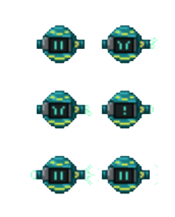

His faceset:

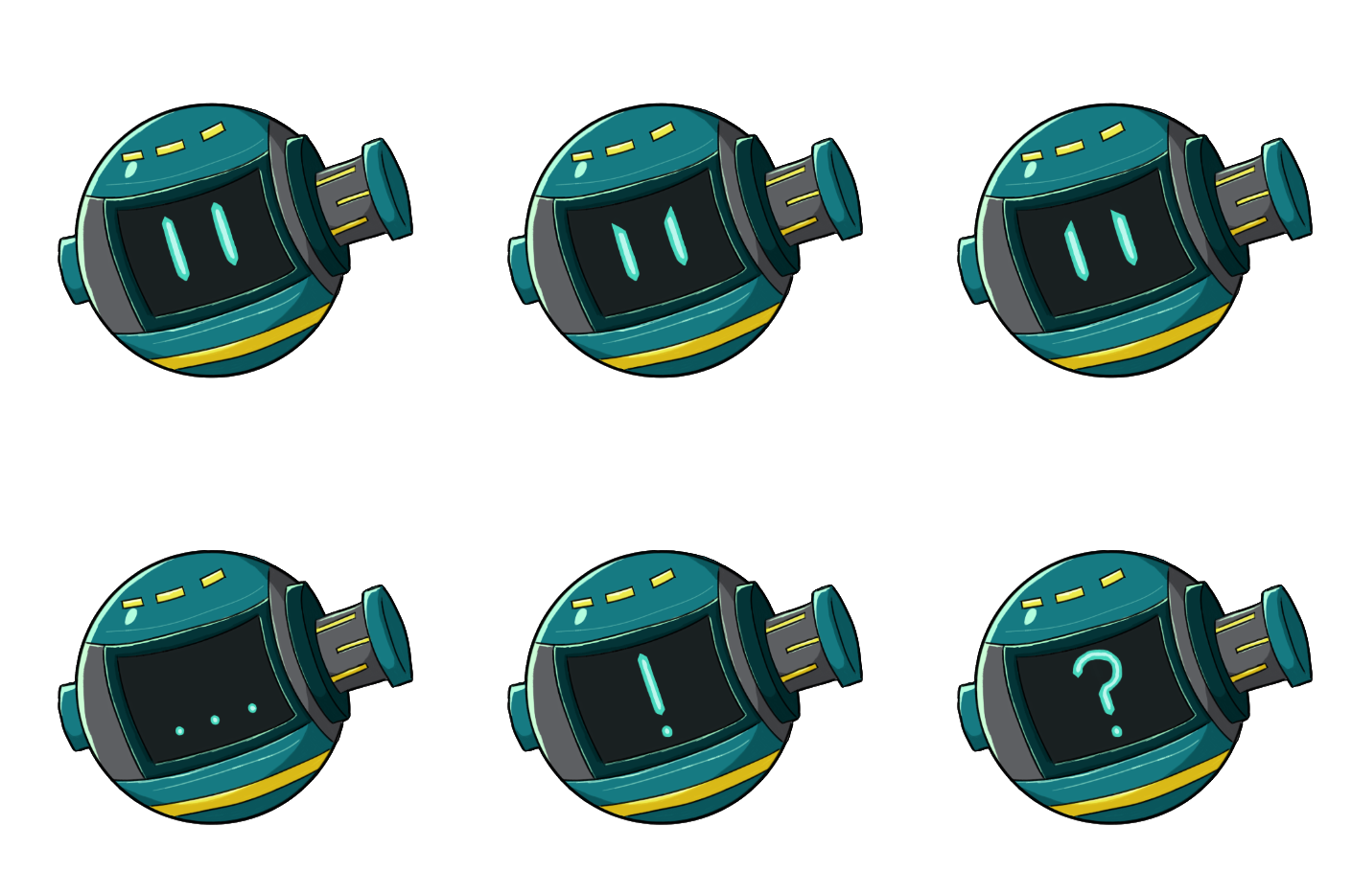

**Enemies:**  
  
Every monster were designed with three ideas in mind: Which animal does it represent, what natural elements constitute its body, and what gameplay purpose does it serve. Furthermore, every monster were given eyes that not only are placed in unnatural positions, the number of eyes also represent how heavy the monster is, and therefore how far they will fly from Energy Blast.

The cat monster replaced fur with leaves, its tail with vines, and it grew two new tails with a small tree part at the end to display that it fires three bullets at once every time it attacks.

The bird monster was designed to be like a flower, and its tail, now a vine, shows the flow of movement as it flies around.

The Spider monster was designed with a face shield first as it blocks all attacks coming from the front, making bulky wooden planks its main natural element.

The Beetle monster kept the wooden plank idea from the Spider monster, with only a small part of its head being visible over the legs. The delimitation of its weak points is made clear from the contrast of color, and large horns were given to it to give a much higher shooting point without forcing it to make its weak point stand out.

Cat monster: Bird monster:

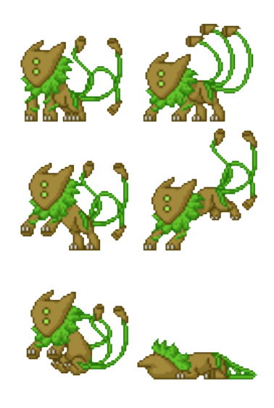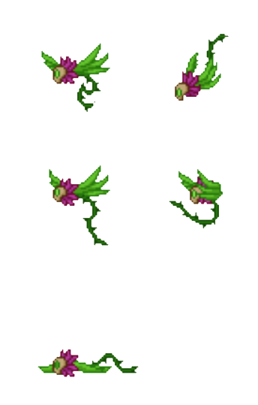

Spider monster: Beetle monster:

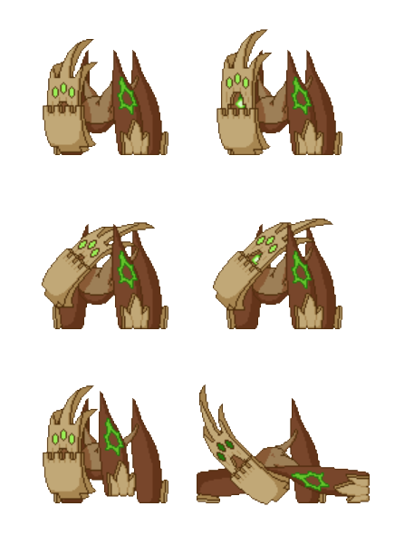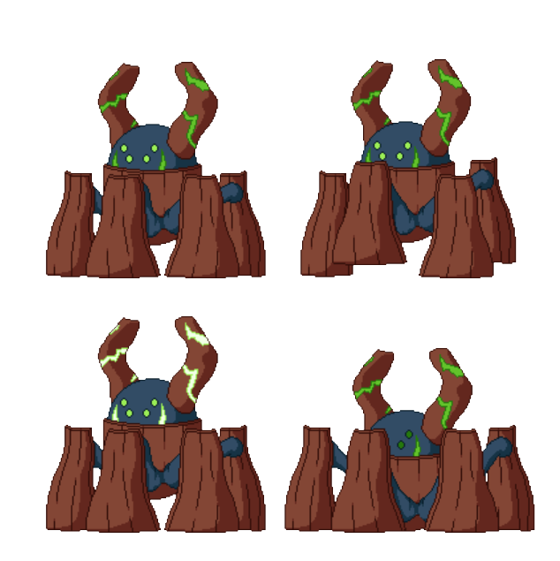

# 

# Skills:

Energy Blast:  
  
Energy Blast was given a very circular look, as it expands from the center point. The fast animation makes it easier to understand it’s a force that applies to everything close to the activation center.



# Ice Wall: The Ice wall was made to be as flat as possible, and with strong white reflects to make it easier to understand that lasers ricochet off of it.



Crosshair:  
The crosshair shows a large ring to make it easier to localize it as it may move fast across the scene, and a small plus sign in the middle to be able to tell where exactly the player is aiming. Its color changes according to the equipped Support skill, with the crosshair color matching the color of the skill’s special effect’s color.

# 图片 15

UI storyboards

The main menu is simple with just an image of our character, the title, and 3 buttons: Start, Control and Developer.(Note that Control and Developer don’t work)

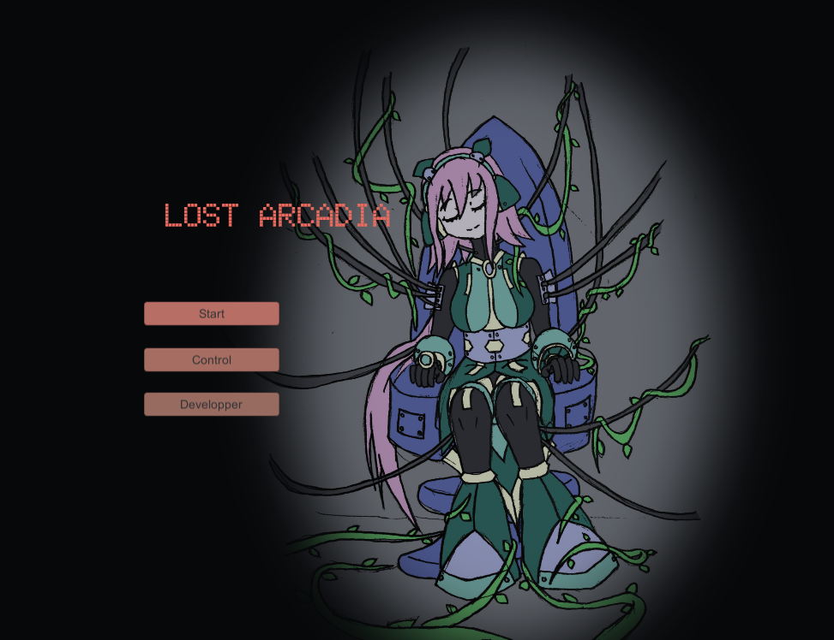

In game HUD will give information on HP, EP(which is used to cast support skills), special bullets number.

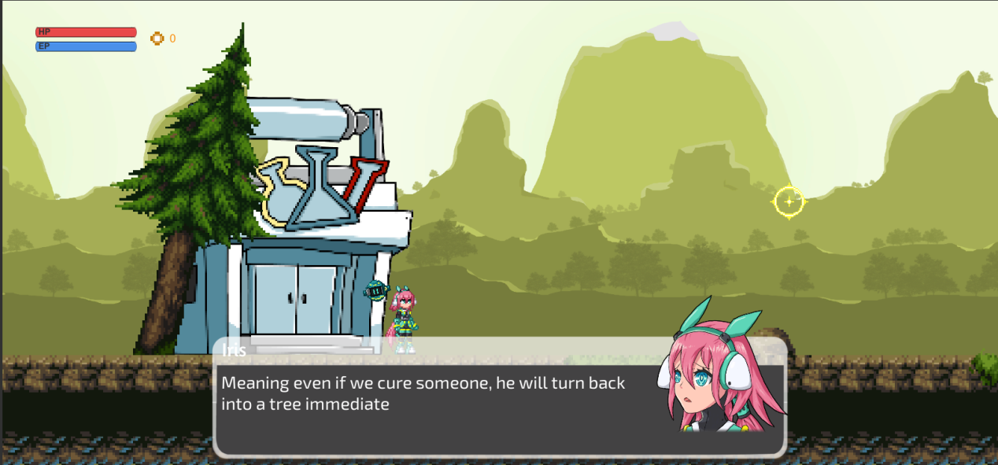

Tags and dialogue

Lost Arcadia utilizes Fungus as the dialogue system, which does not utilize tags per line, and is not expected to be localized. Instead, dialogues are bundled and identified together per event. By the linear nature of the game, each event are triggered in order.

See the Dialogs document for more details for each event. The document can be found in the Documentation folder of the project.

**Stage 1**  
  
**Event 010:**  
Iris receives an examination by two of her laboratory’s scientists, who ask her a few questions in order to see how her robotic body is behaving. After a few questions, they put her back to sleep, but she wakes up 3 months later, after a monster sneaked into her laboratory and caused a shock by destroying the machinery she was connected to. She notices trees and vegetation, but no human around.

**Event 020:**  
Iris picks up the Self Defense Drone, and connects it directly to her mind.

**Event 030:**  
Iris confirms the death of the monster, and decides to search for a survivor.

**Event 040:**  
Iris hears Hiroki call for her help.

**Event 050:**  
Iris finds Hiroki inside the computer. He explains that every human turned into trees, and that he used his Soul Transfer chair to save his mind. Iris then transfers Hiroki’s mind onto her Self Defense Drone, and they decide to leave the laboratory.

**Event 060:**  
Hiroki sees a monster for the first time, and suggests analyzing it.

**Event 070:**  
Iris analyses the monster’s corpse and confirms it’s a mix of plant, cat and virus, noticing that the virus is converting the cat cells into plant cells. She also finds some strange energy that Hiroki uses to power up his gun.

**Event 080:**  
Iris and Hiroki arrive at the elevator room, but the elevator is unusable due to the large amount of trees blocking the way. Hiroki suggests finding a certain invention.

**Event 090:**  
Hiroki points where the invention is.

**Event 100:**  
Iris finds the Space-Flux Manipulator, and Hiroki explains that it can manipulate particles at any point in space. Iris installs it on her wrist, but hasn’t figured out how to use it.

**Event 110:**  
Iris finishes analyzing the first functionality of the Space-Flux Manipulator, and Hiroki wants to see it.

**Event 120:**  
Hiroki explains that what she used is called Energy Blast. He suggests using it to reach the walkway that is too high to reach by jumping.

**Event 130:**  
Hiroki comments on Iris’ use of the Energy Blast.

**Event 140:**  
Iris finishes analyzing the Ice Wall functionality.

**Event 150:**  
Security doors close due to the Laser Security System.

**Event 160:**  
Hiroki comments on Iris’ use of the Ice Wall.

**Event 170:**  
Iris aborts the analysis of the Space-Flux Manipulator due to her analysis system overheating.

**Event 180:**  
Iris and Hiroki finds a large monster, and while Hiroki is panicking, Iris decides she must analyse it.

**Event 190:**  
After defeating it, Iris analyses the monster and confirms it’s made of plant, virus and stag beetle cells.

**Event 200:**  
Iris and Hiroki finally step outside of the laboratory, and see that the virus turning people into trees has affected the whole world. Iris decides that she must save everyone.

**Stage 2**

**Event 010:**  
Iris explains her plan of action, and also makes note that that virus is still being propagated by something.

**Event 020:**  
Hiroki suggests heading into the Cybermath Laboratory

**Event 030:**  
Hiroki explains that the Cybermath Laboratory has a super computer.

**Event 040:**  
Iris and Hiroki find a large group of monsters are trying to get into a room. They figure out that the super computer must be inside, and they try to find a way in.

**Event 050:**  
Hiroki notices a key card on the floor

**Event 060:**  
Iris picks up the card, noticing that the tree besides it must be its owner.

**Event 070:**  
Iris and Hiroki notices the strong heat of the server room.

**Event 080:**  
Iris completes the analysis of the Space-Flux Manipulator using the super computer and discovers the Gravitational Field ability. However, they notice the monsters are swarming in from the door they entered.

**Event 090:**  
Iris reaches a dead end, and Hiroki suggests using the Gravitational Field to escape from the top.

**Event 100:**  
Hiroki comments on Iris’ use of the Gravitational Field.

**Event 110:**  
Iris describes her next objective, being to find a good sample to analyse.

**Event 120:**  
A monster with a unique appearance appear in front of Iris and Hiroki. Iris believes this is the perfect sample that she’s been looking for.

**Event 130:**  
After defeating the monster, Iris analyses the body, but finds out that the monster was actually a human. After Hiroki snaps her out of her feeling of guilt, Iris completes the analysis, and then says that they need to head to the Delta Genetics Laboratory.

**Stage 3**

**Event 010:**  
Hiroki explains that he worked for the Delta Genetics Laboratory, saying that they would always skip safety steps. On the way to the Virus Generator room, Iris explains how exactly the virus works.

**Event 020:**  
Iris makes notice that they are now in front of the Virus Generator Room.

**Event 030:**  
Iris and Hiroki notice that the Virus Generator is completely blocked by trees, while monsters are swarming in and trying to prevent them from reaching it.

**Ending A:**  
Activated by destroying the Virus Generator. Iris gives up on trying to reuse the generator, and they escape before it explodes. In a monologue, Iris explains that she tried to cure people, but it was not possible due to the entire environment being infected by the virus, and her body not being able to produce the cure fast enough. She apologizes repeatedly as her system starts dying.

**Ending B:**  
Activated by pressing the Virus Generator’s power switch. Iris analyses the machine to find out it can be used to propagate the cure, and gives it a try. However, they notice the generator’s malfunction and escape before it explodes. In a monologue, Iris explains that she managed to cure a few people, and that despite that the food was also infected by the virus, the generator still propagated enough anti-bodies to cure their city, and they were able to revive enough people to create a settlement. Having finally seen a glimpse of hope, Iris claims that both humanity and nature were revived, and that they will eventually have regained the Arcadia that they lost.

Technology plan

Game development technologies:

-Unity 2018.4.12f1

-Visual Studio 2017

Project management tools:

-Discord

-Google docs

-Microsoft office

Asset tools:

-Adobe Photoshop

-Piskel

-Autodesk Sketchbook

-Fungus

Since we have a lot of dialogues telling the player why the world is like what it is and we don’t want to spend too much time repeating the work, we use Fungus in Unity assets store.

Collaborating tool:

-Unity Collab

At first we used Github and Github desktop, but there was a high risk that problem occur when merging, so finally we turned to Unity Collab.

Hardware:

-Laptops/PCs

-Graphic tablets

Software architecture

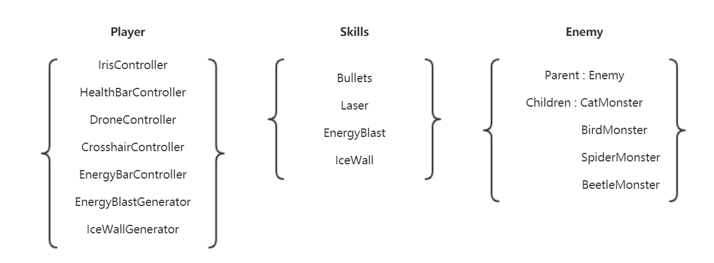

There are four main parts: Player, Skills, Enemy and Scenes.

We have controllers that control the movement of the character, the drone, take care of player related attributes and let out skills.

Bullets and Laser are designed for both the player and the monsters, with basic functions. Energy Blast and Ice Wall are instantiated in related generator.

For Enemy, we first wrote a parent class that contains several functions that every monster share, then complete each of them based on their behaviour.

Scripts for scenes are basically designed for events.

Controls

Movement:

Like most shooting games on PC, we use AD for moving left and right, players could press the key two times to dash. To jump, the only way is to press W, and S is for crouch.

Skills:

For skills, the player need to use both keyboard and the mouse. To shoot a bullet, quickly click mouse left button once. If player does a long press, before releasing the button, a preview telling how the laser is going to go will be presented, upon releasing, a laser will be shot.

To cast support skills, first press 1/2 on keyboard to choose Energy Blast/Ice Wall, then click mouse right button to use them. When the player wants to use the Ice Wall to reflect a laser, she/he can hold the button for the right angle.

We keep track of the player’s position and the mouse’s position to finalize the direction of bullets and laser. Preview of Ice Wall and Laser are also controlled by mouse movement.

Interaction:

To absorb the dead monsters, if the player stands close enough, an E will show, only then the player could press E to get bonus ability.

Level Design:

Lost Arcadia consists of two stages. Stage1 sets the story and teaches players how to use all game mechanics. On the other hand, stage 2 is the main game play level.

stage 1:

Stage 1 is considered to be a tutorial stage. The main propose is to teach players how to move and how to act. At the same time, it gives the story background. It starts with lab, corridor and end with boss room. The design idea behind stage 1 is that we try to minimize the length of stage1 and try to give enough informations on how to fight and why we fight. Therefore, there is no connection between room, instead, we transfer player to next room directly from the end of each room.

Platforming: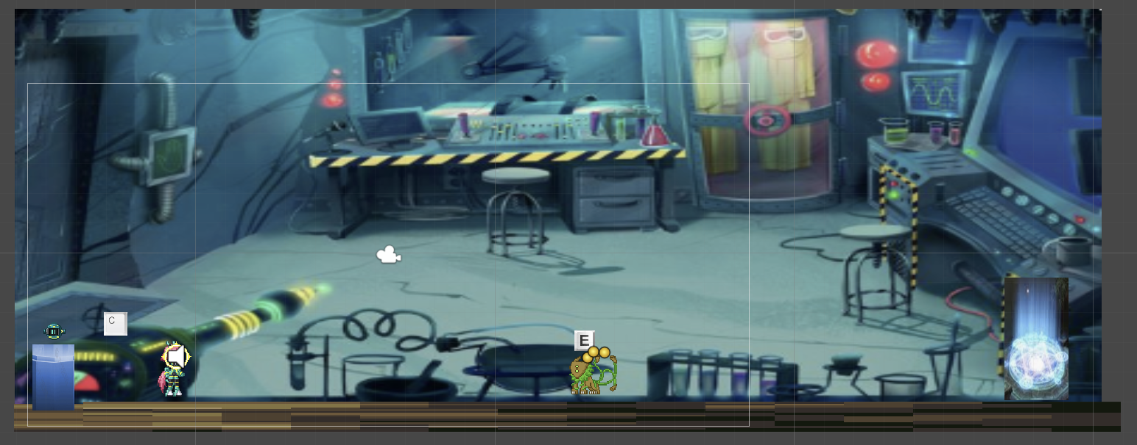

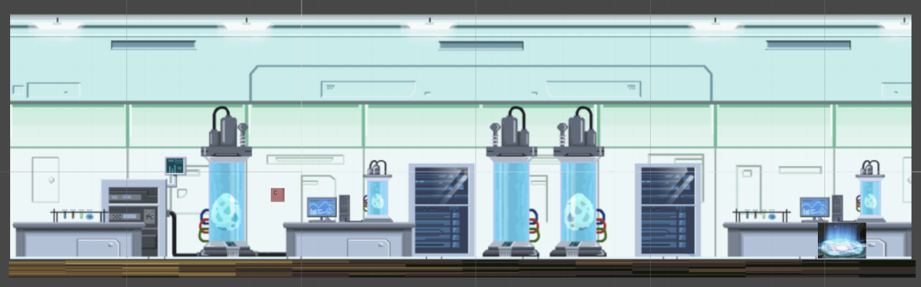

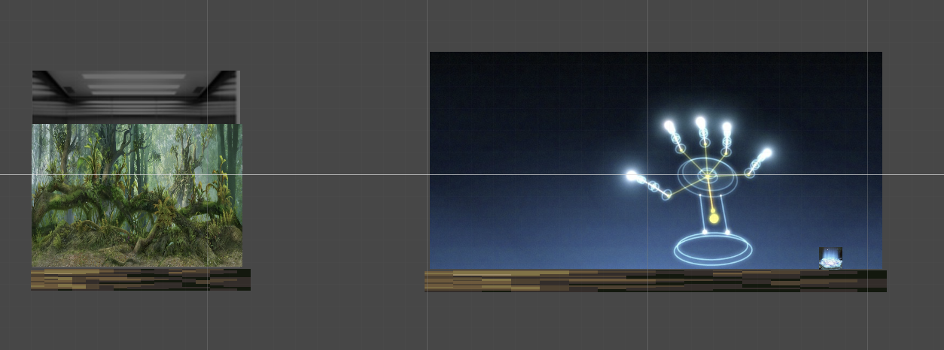

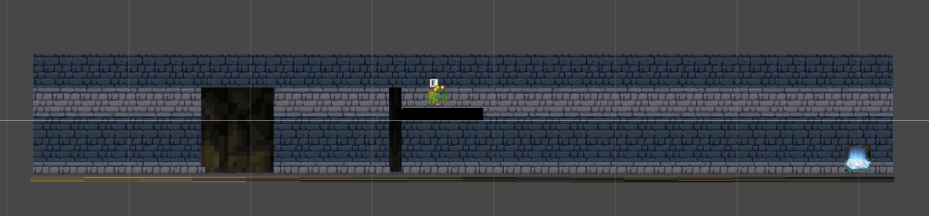

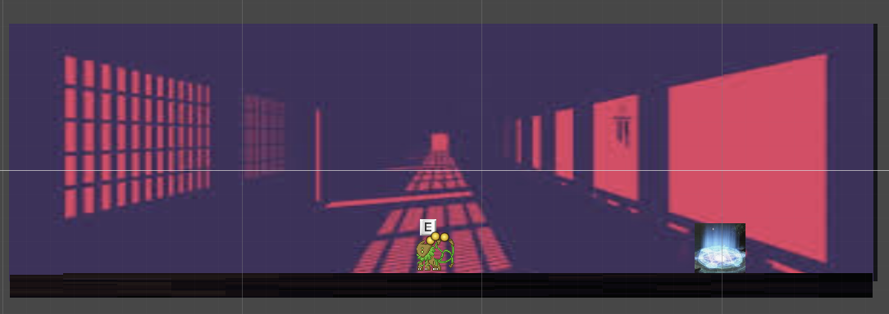

The boss room:

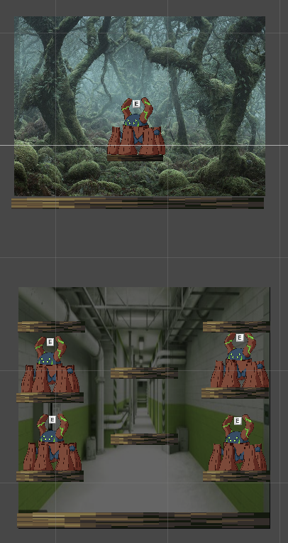

The boss room contains the first floor and the basement, all the monsters only have hp of 1 because it’s a tutorial stage, it should give players ideas on how to play, not to challenge them. When the top boss dies, the base is destroyed, the player is dropped to basement, when four beetles are died, the transition to stage will appear.

stage 2:

Stage 2 starts just outside iris’ lab and ends inside the cyber math lab. The player has to fight many monsters and find the key to get inside the CML. Stage 2 is a mix between platforming and fighting and puzzle solving.

Platforming:

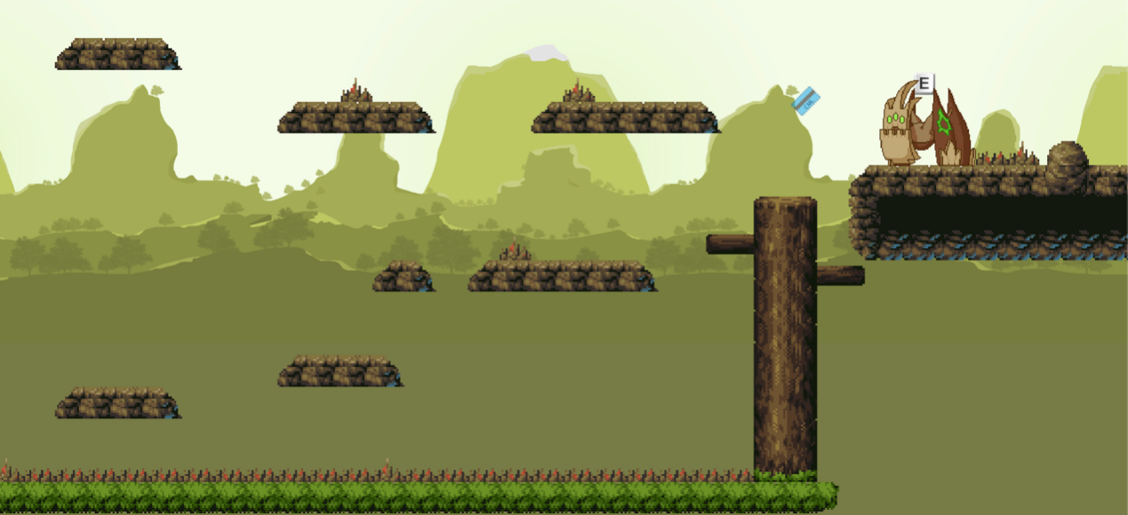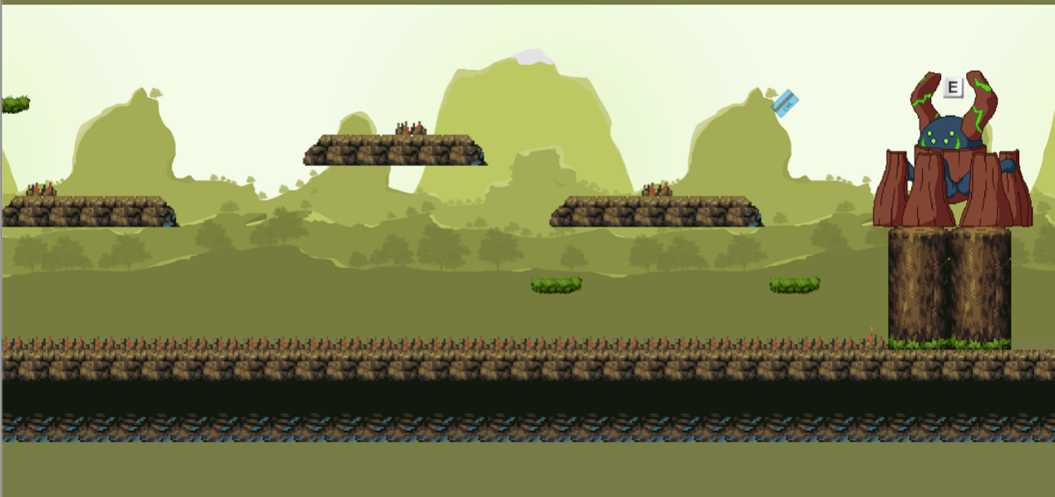

Puzzle:

Player has to find the key to get into the lab.

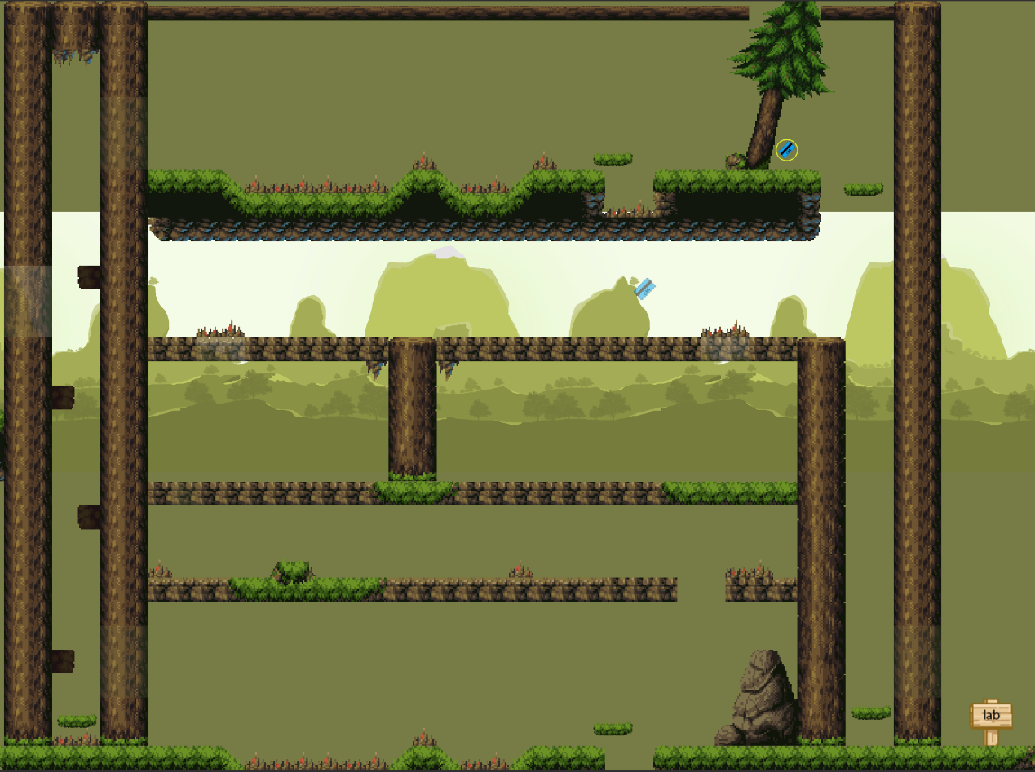

Stage 2 boss:

Stage 2 boss is 2 beetle monsters on high ground. One of them has 2 different attacks, the regular attack and it can throw cat monster egg as well. Once the egg hits the ground it turns into cat monster that attacks the player. The cat monster is a threat and opportunity for the player. It is obviously a threat because it attacks the player, but the opportunity is in powering up bullets after clicking E on cat’s monster dead body.

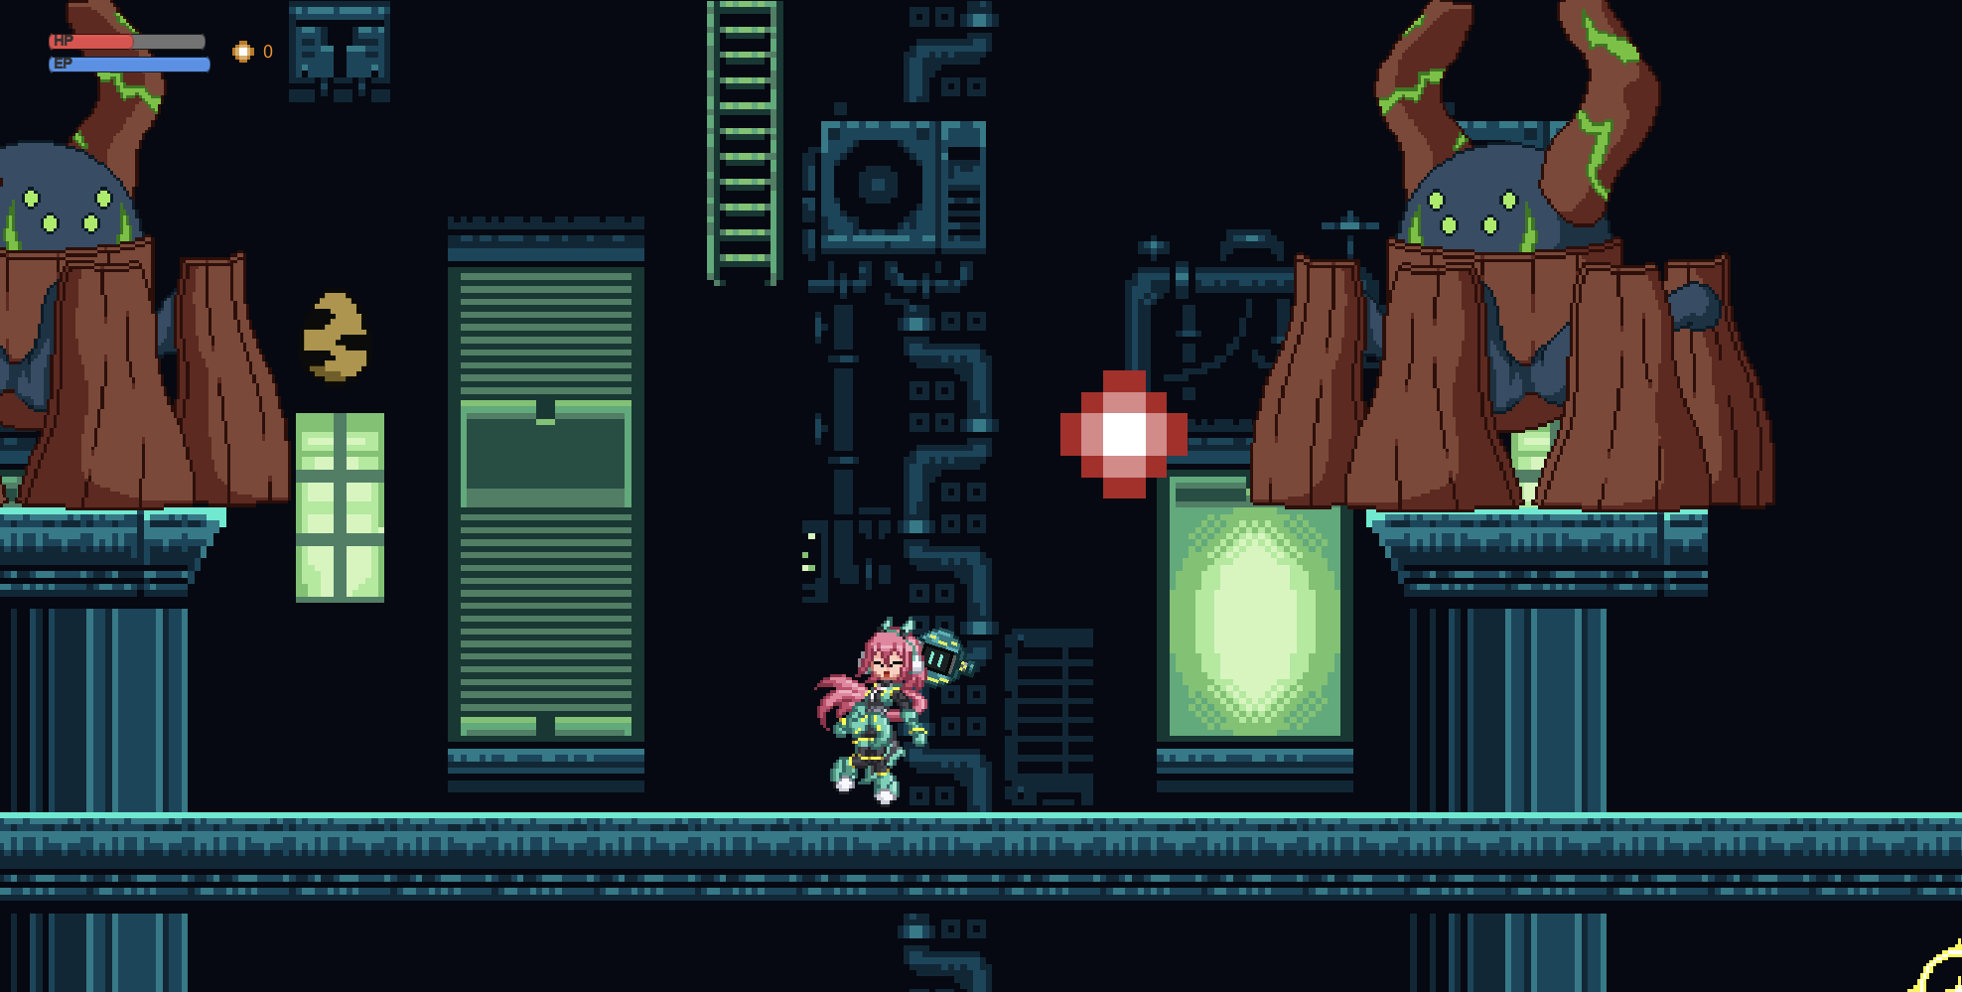

Mechanics analysis

### Jumping

- <Details>

/Going up vertically to get to a higher place or to shoot/ dodge an enemy or attack/

- <How it works>

/Works like most platformer games do/

Shooting

- <Details>

/Defeat the enemies by shooting with the drone/

- <How it works>

/Using the mouse (left) to aim and shoot in the direction of the cursor. Quick click for bullet, hold and release for laser. The attacks come from the Drone which floats around Iris./

Mouse-controlled skills

- <Details>

/Three main abilities: Energy Blast, Ice Wall and Gravitation Field(which we didn’t have time to finish)/

- <How it works>

Select ability with Hot keys 1 (Energy Blast), 2 (Ice Wall) and 3 (Gravitational Field).

Absorb enemies for temporary power-up

- <Details>

/Iris can absorb enemy corpses to temporarily gain a special effect on her bullets. Effects are dependant on the enemy type, and are simple effects such as increased damage, knockback and inflicting slow buff./

- <How it works>

/After being defeated, if an enemy has an absorbable bullet type, it will fall dead on the ground instead of disappearing. The enemy corpse can be absorbed by pressing E nearby. The bullet buff will immediately be applied and will last until replaced by a new bullet buff or until depleted. The bullet buffs last for 24 bullets. A laser depletes 5 bullets./

Schedule

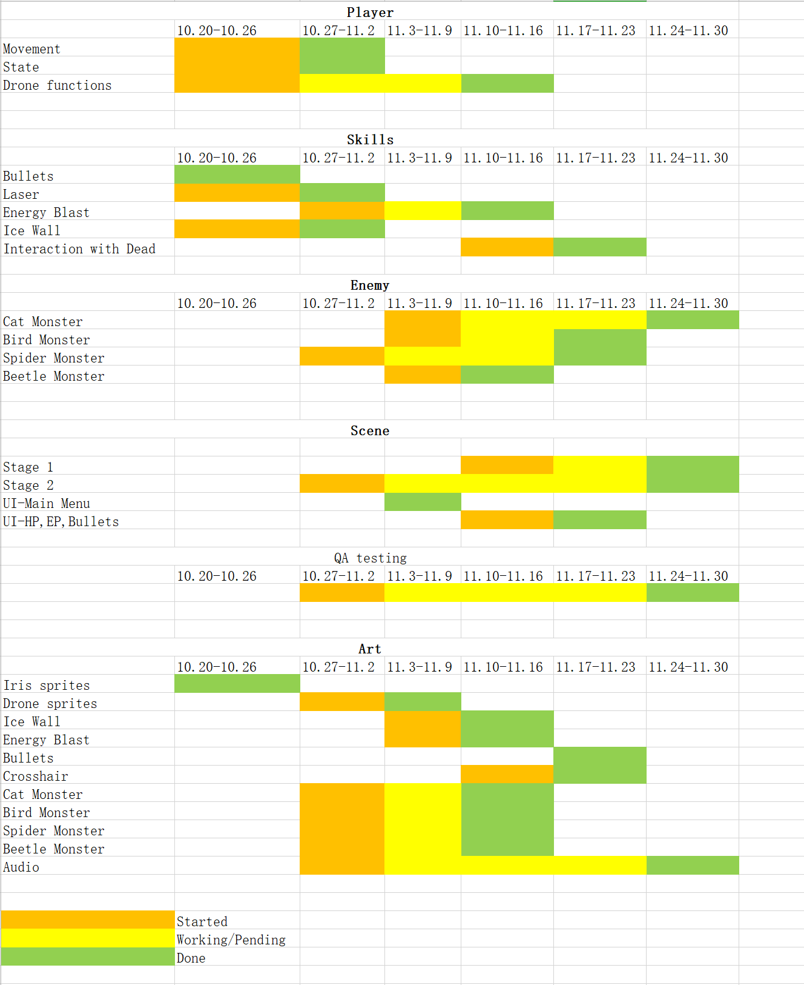

Budget

|  |  |
| --- | --- |
| **Items** | **Cost** |
| Salary | $85,000 |
| Recruiting Cost | $7,000 |
| Art Assets | $10,000 |
| Contractors | $20,000 |
| Marketing | $20,000 |
| **Total** | **$142,000** |

Change logs

-Player can no longer use Ice Wall as a platform, for a more balanced game

-Dialogue tree removed for a smoother experience

-Gravity Field will not be in the game for time reason

-Stage 1 is going to be more of a story telling level, stage 2 will concentrate more on gameplay

-Stage 3 will not be in the game for time reason

Meetings

Met 26/9/2019 at 18:00

Everyone was present.

Discussed game ideas. From the already existing 3 ideas, 5 more ideas arose during the meeting.

Met 01/10/2019 at 13:30

Everyone was present.

Discussed story of the game. Decided of Team Member roles. Prepared the Project Proposal Presentation.

Met 03/10/2019 at 18:00

Everyone was present.

Decided details about the story, finalized and practiced the presentation

Met 22/10/2019 at 13:30

4/6 of our team were present.

Discussed about enemy types and balance of support skill system. Decided on what will be present in the prototype.

Met 29/10/2019 at 13:00

5/6 of our team were present.

Decided of the Unity version to use (2018.4.12). Made the Github project ready for merge. Discussed about the Thursday presentation.

Met 31/10/2019 at 13:00

5/6 of our team were present.

Meeting for preparing demo

Met 18/11/2019 at 13:00

5/6 of our team were present.

Working on games, implementing stage1 and events

Met 19/11/2019 at 13:00

5/6 of our team were present.

Working on games, implementing stage2 and level design

A lot of discussions on discord.

Additional information:

Lead Programmer: Luojia Yan

Lead Designer and Lead Artist: Ghislain Clermont

Audio artist: Jia Gao

Documentation: Xuan Li

QA Tester: Xiyue Li, Xuan Li

Project Manager: Luojia Yan

Level designer: Amrou Abdelhadi

And everyone is a programmer

# Skills & Monster description

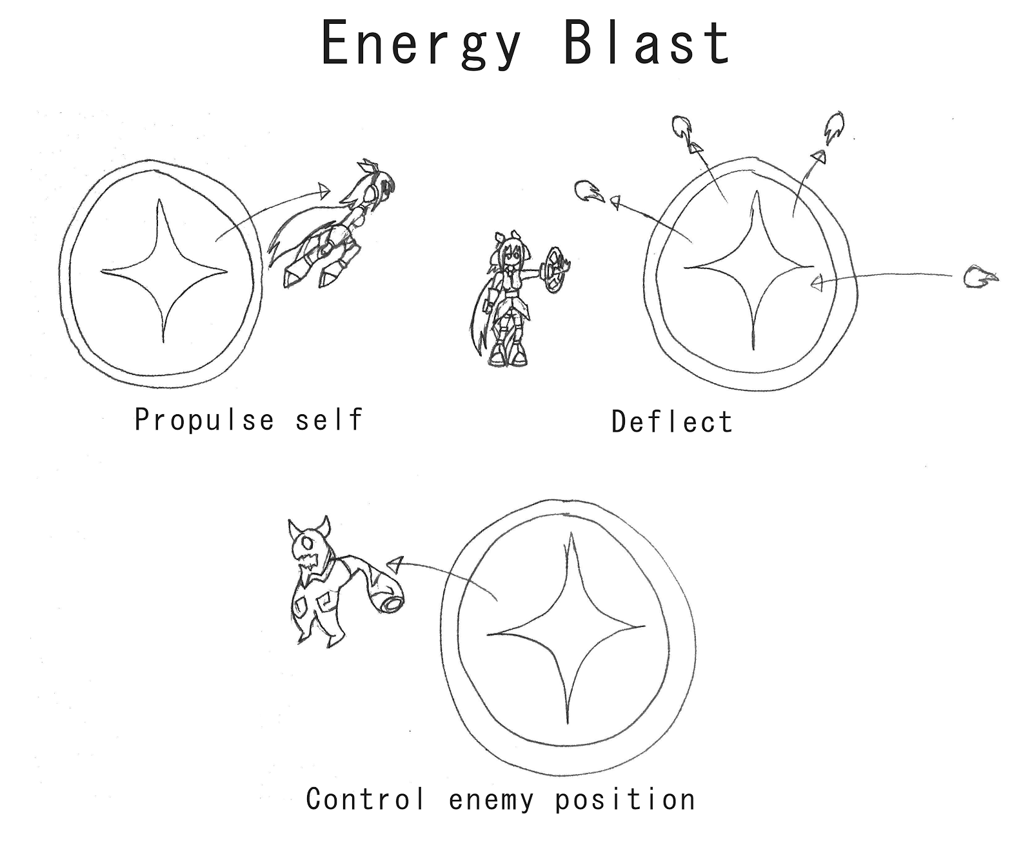

Right click to start charging, release to create a Blast centered where the mouse was released. The longer it is charged, the heavier the obstacles that can be propulsed away. Obstacles include Iris herself, enemies and their bullets.

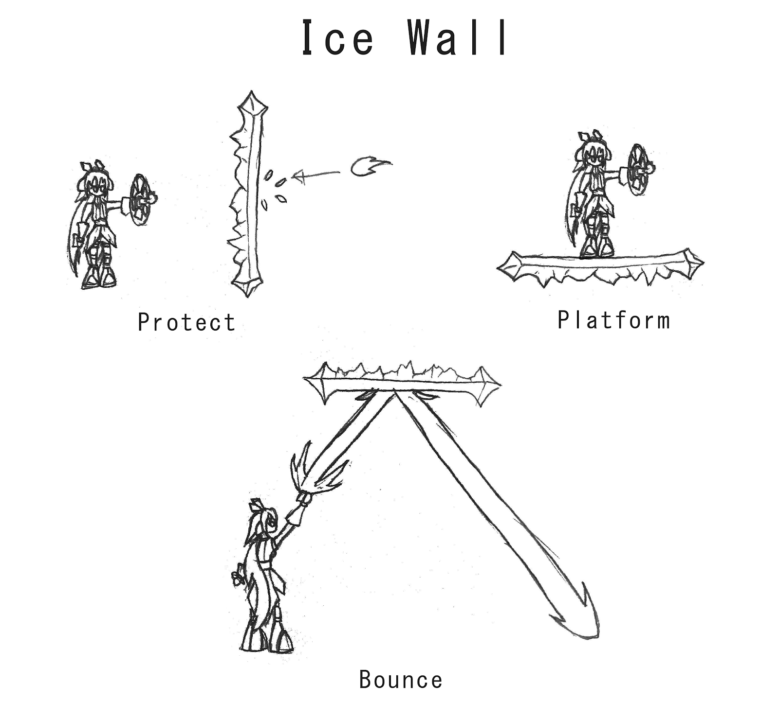

Hold Right click, drag and release to create an ice wall between the click and release points. Blocks all bullets and reflects all lasers. If horizontal enough, it can also be used as a platform(no longer serve as a platform for game balance). Breaks if touched by an enemy or Iris.

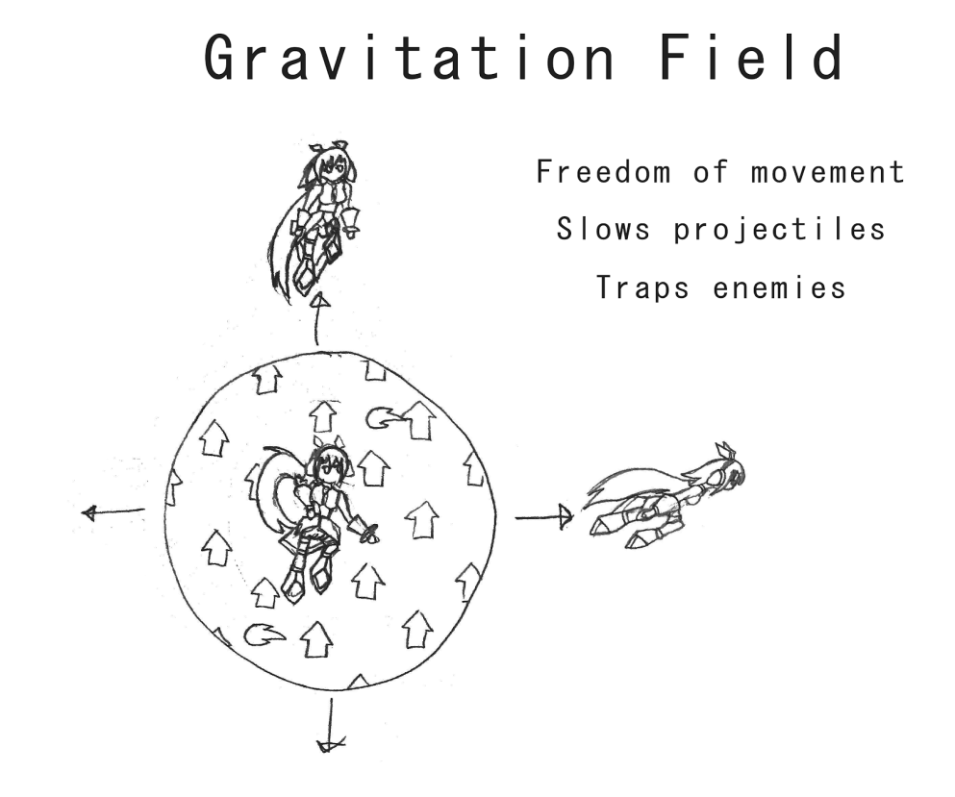

Hold Right click to determine center of circle, drag and release to create a circular field with radius equal to distance between click and release points. The Gravitation Field gradually becomes smaller until it is too small and disappears. Enemy bullets slow down after entering the Field, and enemies are unable to move when inside a field bigger than their own size. Iris is able to freely move in all directions while inside, and can quick dash out of it by double-tapping any directional key, including W (Up) and S (Down).

# Cat monster

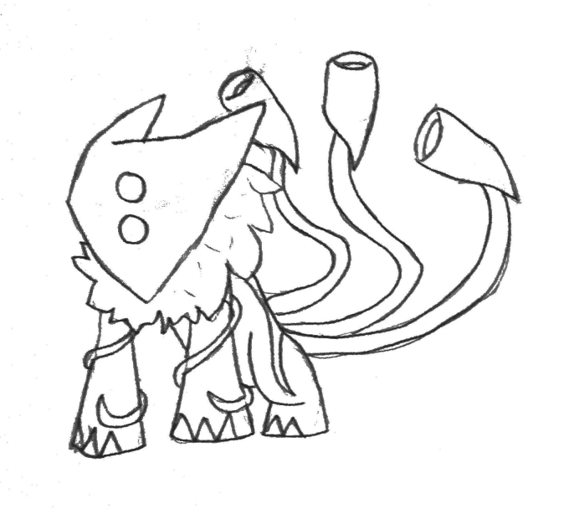

The generic enemy, designed to be weak against all of Iris’ support skills.

- HP: 4

- Weight: Medium

- Movement pattern: Runs onto its current platform in Iris’ direction. When reaching the edge/corner of its platform, it jumps to try and reach the next platform.

- Attack pattern: Gets into position and shoots 3 bullets toward Iris. Direction and timing can vary based on color variation (3-spread, 3 consecutive, etc.)

- AI: Approaches Iris, then after reaching a specific distance, stops moving and starts shooting. If Iris gets too close, jumps toward Iris for a melee attack.

-Weakness: Energy Blast interrupts his shooting and deflects his bullets. Ice Wall blocks his bullets. Gravitational Field prevents him from shooting if too far and slows his bullets.

-Bonus ability when absorbed: Bullets speed up

**Bird monster**



Flying enemy. It flies and charges toward Iris for a melee attack, destroying Ice Walls in the path.

- HP: 2

- Weight: Light

- Movement pattern: Fly at a specific height from left to right.

- Attack pattern: Dives toward Iris’ position at the start of the attack, then flies back to its height. Ice walls in the way are broken. Ignores collision while diving.

- AI: Flies left and right, changing direction when getting too far from Iris. Attacks every 2 seconds after the previous attack finished.

- Weaknesses: Energy Blast will make it fall, preventing it from attacking for a few seconds. Gravitational Field prevents it from moving as long as it’s active. Unaffected by Ice Wall.

- Bonus ability when absorbed: Knock back

**Spider monster**

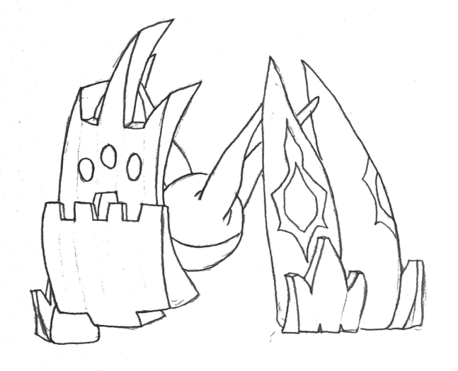

Tougher enemy. It protects itself using its head, making it impossible to defeat without thinking.

- HP: 5

- Weight: Heavy

- Movement pattern: Slowly moves only on the platform he is standing on.

- Attack pattern: Opens its mouth and fires a laser toward the position where Iris was when it started opening its mouth.

- AI: Moves toward Iris until it is in a good distance to shoot. Always looks toward Iris, but takes half a second to turn around should Iris jump over it. Does not change direction while shooting.

- Weaknesses: Energy Blast makes it flip on its back, exposing its back for 4 seconds. Ice Wall can be used to bounce a laser from behind or from the top. Unaffected by Gravitational Field.

- Bonus ability when absorbed: Pierce

**Beetle monster**

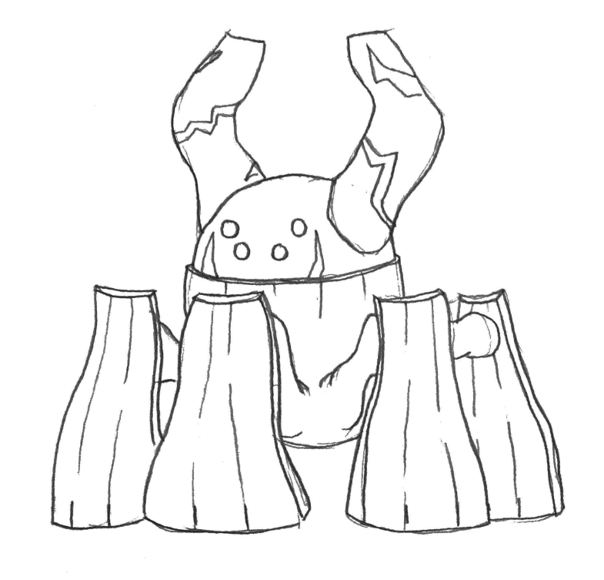

Strongest regular enemy. Serves as the boss of the first level. Its large legs protects it from low shots, making it difficult to get a good shot without gaining height.

- HP: 15

- Weight: Very Heavy

- Movement pattern: Slow moves only on the platform it is standing on.

- Attack pattern: Charges a large bullet between its horns, then fires it toward Iris’ position at the moment the bullet is fired.

- AI: Only moves if Iris is not in its line of sight. Attacks whenever possible.

- Weaknesses: Ice Wall allows to bounce lasers toward its head from upward, and can also block its bullet. Gravitational field allows Iris to stay at a higher height for a clearer shot, and greatly slows its bullet. Energy Blast barely deflects the bullet and does not affect the monster itself.

- Bonus ability when absorbed: Power up

**Human monster**

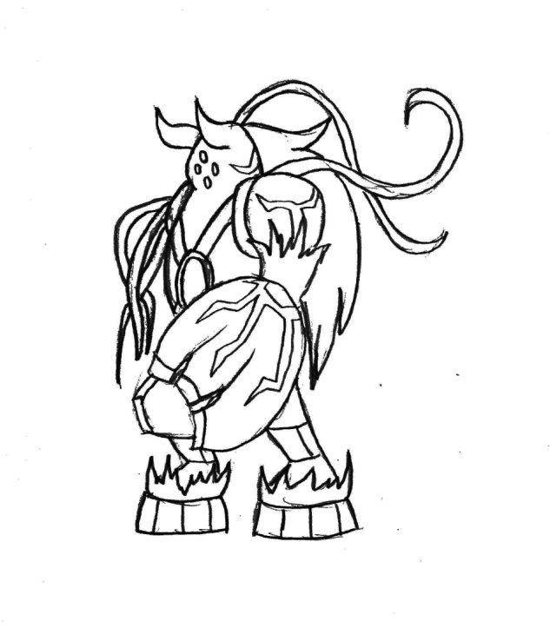

Stage 2 boss monster. By its boss nature, it will require the player to make full use of Iris’ skills to defeat.

- HP: 100

- Weight: Very Heavy

- Patterns: The boss is separated into two phases. Each phase has their own list of possible actions, and the boss will choose randomly between each of these, excluding the last one that’s been used. The first action it chooses will however always be the first listed in the action list.

Phase 1

- Dash: The boss dashes from one side of the screen to the other side of the screen. Going over it without an Energy Blast jump requires a very tight timing.

- Shotgun: The boss aims its arm toward Iris and shoots multiple bullets at once in a shotgun pattern. Blocking with Energy Blast and Ice Wall is possible, but it can also be dodged by jumping at close range.

- Machinegun: Considered to be the same as Shotgun action (the boss alternates between the two when Shoot action is taken). The boss aims its arm toward Iris and shoots 10 bullets in rapid succession, with a certain inaccuracy. Ice Wall and Gravitational Field are effective there, but the attack can also be dodged with precise jumping.

- Ground vines: The boss plants its vines onto the ground, which then come out to attack the whole ground. This attack can be dodged with a tight timing for a regular jump, but is easier to dodge with Energy Blast or Gravitational Field.

Phase 2

- Bullet Rain: The boss fires upwards, and every bullet comes falling down like rain. Just like in Phase 2, there are two variations: one where the boss shoots all bullets at once, and another where it shoots multiple times consecutively. The Shotgun pattern can be dodged by finding an hole within the cluster, while the machine gun will require to dodge continuously, but skills can still be used.

- Jump: The boss jumps from one side of the screen to the other side, shooting one large bullet toward Iris at the peak of its jump.

- Vine Web attack: The boss aims its vine arm toward Iris, which then all extend linearly until they either hit the ground or the other side of the screen, and retracts them after a second. Gravitational Field is the only skill that can help in this situation, but otherwise, it is possible to dodge by finding a spot to crouch and dodge the vines.

# 

# What sets this project apart?

- Platformer mechanics with Shooter controls for unique gameplay.

- Flexible, easy to use mouse-based support skills

- Unique post-apocalyptic story

- Likable main character